Northern Ireland breast screening

Helping you decide

Contents
- What is breast cancer?
- What is breast screening?
- Breast screening results
- Making a choice – the possible benefits and risks of breast screening
- Weighing up the possible benefits and risks of breast screening
- What are the symptoms of breast cancer?
- What happens to my mammograms after screening?
- Who can I contact if I have a question?

It is your choice whether to have breast screening or not. This leaflet aims to help you decide.

Why does Health and Social Care (HSC) offer breast screening?
The HSC offers screening to save lives from breast cancer. Screening does this by finding breast cancers at an early stage when they are too small to see or feel. Screening does not prevent you from getting breast cancer.
Breast screening does have some risks. Some women who have screening will be diagnosed and treated for breast cancer that would never otherwise have been found, or caused them harm.

Why have I been invited for breast screening?
All women aged 50 to 70 are invited for breast screening every 3 years.
If you are over 70, you are still at risk of breast cancer. Although you will no longer automatically get screening invitations after you are 70, you can still have breast screening every three years. You will need to ask your local breast screening unit for an appointment.

What is breast cancer?
Breast cancer starts when cells in the breast begin to grow in an uncontrolled way and build up to form a lump (also known as a tumour). As the cancer grows, cells can spread to other parts of the body and this can be life-threatening.
Breast cancer is the most common type of cancer in the UK. About 12,000 women in the UK die of breast cancer every year. Survival from the disease has been improving over time, and now about 3 out of 4 women diagnosed with breast cancer are alive 10 years later.
Your risk of getting breast cancer goes up as you get older. About 4 out of 5 breast cancers are found in women over 50 years old. Most women with breast cancer do not have a family history of the disease.

What is breast screening?
Breast screening uses an X-ray test called a mammogram to check the breast for signs of cancer. It can spot cancers that are too small to see or feel.

What will happen if I choose to have breast screening?
When you arrive at the breast screening unit, the staff will check your details and ask you about any breast problems you have had. If you have any questions, please ask.
Mammograms are carried out by women called mammographers. To have a mammogram, you need to undress to the waist. So it may be easier to wear a skirt or trousers instead of a dress.
The mammographer will first explain what will happen. She will then place your breast onto the mammogram machine and lower a plastic plate onto it to flatten it. This helps to keep your breast still and get clear X-rays.
The mammographer will usually take two X-rays of each breast -- one from above and one from the side. She will go behind a screen while the X-rays are taken. You have to keep still for several seconds each time.
The whole appointment takes less than half an hour and the mammogram only takes a few minutes.

What does having a mammogram feel like?
Having a mammogram can be uncomfortable, and some women find it painful. Usually, any pain passes quickly.

Please phone your breast screening unit before coming for your appointment if:
- you have a physical disability or find climbing steps difficult, so that your screening unit can make any necessary arrangements for you;
- you have breast implants, you will usually be able to have a mammogram but please let the screening staff know beforehand;
- you have had a mammogram recently, or are pregnant or breastfeeding, as you may be advised to delay breast screening; or
- you need an interpreter.

Breast screening results
You will receive a letter with your breast screening results within 2--3 weeks of your appointment. The results will also be sent to your GP.

Most women will have a normal result
In about 96 out of every 100 women screened the mammogram will show no sign of cancer -- this is a normal result.
Remember that cancer can still develop between mammograms, so tell your GP straight away if you notice any breast changes.

Some women will need more tests because they have an abnormal result
The results letter may say you need more tests because the mammogram looks abnormal. About 4 in every 100 women are asked to come back for more tests after screening.
Out of these 4 women, 1 will be found to have cancer. The rest will not have cancer and will go back to having screening invitations every 3 years.
If you are called back for more tests, you may have a breast examination, more mammograms and ultrasound scans.
You may also have a biopsy, which is when a small sample is taken from your breast with a needle to be checked under a microscope. While we try to provide the test results to you within a week, occasionally fine needle test/biopsy results may take up to two weeks to come back.

Occasionally women will need another mammogram before they get their result
Sometimes technical problems mean that the mammogram is not clear enough to read. If this happens, you will be asked to have another mammogram to get a clearer picture of your breast.

What happens to 100 women each time they have breast screening?
Diagram
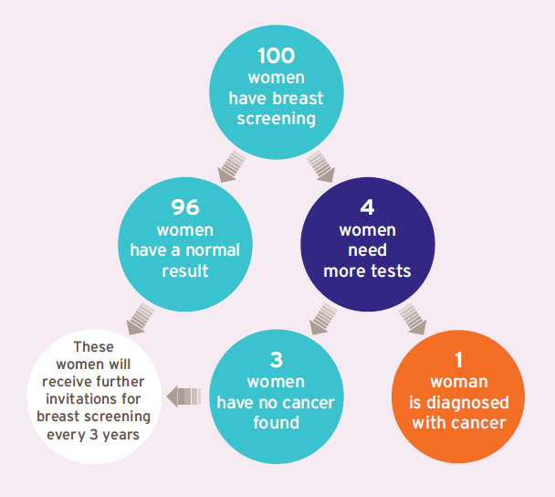
The diagram shows that if 100 women have breast screening, 96 will have a normal result and 4 women will need more tests. Of these 4 women, 1 will be diagnosed with cancer. The other 3 will have no cancer found. They and the 96 women with a normal result will be invited back for routine screening in 3 years’ time.

If you are found to have breast cancer, it could be either non-invasive or invasive

Non-invasive breast cancer
About 1 in 5 women diagnosed with breast cancer through screening will have non-invasive cancer. This means there are cancer cells in the breast, but they are only found inside the milk ducts (tubes) and have not spread any further. This is also called ductal carcinoma in situ (DCIS). In some women, the cancer cells stay inside the ducts. But in others they will grow into (invade) the surrounding breast in the future.
Doctors can’t tell whether non-invasive breast cancers will grow into the surrounding breast or not.

Invasive breast cancer
About 4 in 5 women diagnosed with breast cancer through screening will have invasive cancer. This is cancer that has grown out of the milk ducts and into the surrounding breast. Most invasive breast cancers will spread to other parts of the body if left untreated.
Diagram
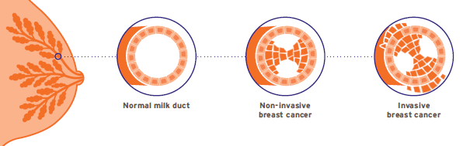

Breast cancer treatment
Whether your cancer is invasive or non-invasive, you will be offered treatment and care from a team of breast cancer specialists. The treatment is likely to include surgery (which may mean a mastectomy), hormone therapy, radiotherapy and possibly chemotherapy as well. These treatments can cause serious, long-term side effects.

Making a choice – the possible benefits and risks of breast screening
It is your choice whether or not you have breast screening. There are many different reasons why women decide whether or not to have screening. To help you decide, we’ve included information on the possible benefits and risks.

Screening saves lives from breast cancer
Lives are saved because cancers are diagnosed and treated earlier than they would have been without screening.

Screening finds breast cancers that would never have caused a woman harm
Some women will be diagnosed and treated for breast cancer that would never otherwise have been found and would not have become life-threatening. This is the main risk of screening.
Doctors cannot always tell whether a breast cancer that is diagnosed will go on to be life-threatening or not, so they offer treatment to all women with breast cancer. This means that some women will be offered treatment that they do not need.

Weighing up the possible benefits and risks of breast screening
Diagram
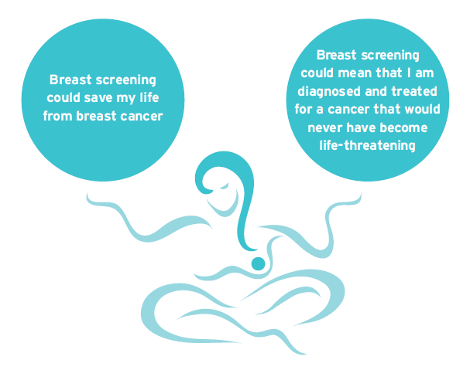

There is debate about how many lives are saved by breast screening and how many women are diagnosed with cancers that would never have become life-threatening. The numbers below are the best estimates from a group of experts who have reviewed the evidence.

Saving lives from breast cancer
Screening saves about 1 life from breast cancer for every 200 women who are screened. This adds up to about 1,300 lives saved from breast cancer each year in the UK.

Finding cancers that would never have caused a woman harm
About 3 in every 200 women screened every 3 years from the age of 50 to 70 are diagnosed with a cancer that would never have been found without screening and would never have become life-threatening. This adds up to about 4,000 women each year in the UK who are offered treatment they did not need.
Overall, for every 1 woman who has her life saved from breast cancer, about 3 women are diagnosed with a cancer that would never have become life-threatening.
Researchers are trying to find better ways to tell which women have breast cancers that will be life-threatening and which women have cancers that will not.

Can breast screening have other risks?
- Most women who receive an abnormal screening result are found not to have breast cancer. These women experience unnecessary worry and some feel distress which affects their ability to do their normal day-to-day activities at the time.
- X-rays can very rarely cause cancer. Having mammograms every 3 years for 20 years very slightly increases the chance of getting cancer over a woman’s lifetime.
- Rarely, breast screening can miss cancers. It picks up most breast cancers, but it misses breast cancer in about 1 in 2,500 women screened.

What are the symptoms of breast cancer?
If you get to know how your breasts normally look and feel, you will be more likely to spot any changes that could be signs of breast cancer. This is important even if you have been for breast screening. Look out for the following:
- A lump or thickening in the breast.
- A change in the nipple. The nipple might be pulled back into the breast, or change shape. You might have a rash that makes the nipple look red and scaly, or have blood or another fluid coming from the nipple.
- A change in how the breast feels or looks. It may feel heavy, warm or uneven, or the skin may look dimpled. The size and shape of the breast may change.
- A swelling or lump in the armpit.
Pain on its own is not usually a sign of breast cancer. If you have any change to your breast, you should make an appointment to see your GP straight away. You may not have cancer. But if you do, being diagnosed and treated at an early stage may mean that you are more likely to survive breast cancer.

What happens to my mammograms after screening?
The Northern Ireland Breast Screening Programme will keep your mammograms for at least 8 years. These are saved securely. The programme regularly checks records to make sure the service is as good as possible. Staff in other parts of the health service may need to see your records for this, but your records will only be shared with people who need to see them.
We will review your previous screening results if you are diagnosed with breast cancer between screening appointments. You can see the results of this review if you wish.

Who can I contact if I have a question?
If you have questions about screening, please contact your local breast screening unit. If you would like to talk to someone about whether to have breast screening, your GP can help. Together, you can weigh up the possible benefits and risks, to help you decide.
You can find more detailed information on breast screening at:
The Northern Ireland Breast Screening Programme www.nidirect.gov.uk/breast-screening -- you can also find details of your local breast screening service on this site.
The NHS Breast Screening Programme
www.nhs.uk/breast
If you would like this leaflet in other languages or alternative formats, visit www.pha.site/breast-screening-publications or contact your local screening unit.
Belfast Health and Social Care Trust (also covering South Eastern HSC Trust)
The Screening Centre
12-22 Linenhall Street Belfast BT2 8BS
Tel: 028 9033 3700
Email: breastscreeninglhst@belfasttrust.hscni.net

Northern Health and Social Care Trust
Northern Area Breast Screening and Assessment Unit
Level A, Antrim Area Hospital 45 Bush Road, Antrim BT41 2RL Tel: 028 9442 4425
Email: breast.screening@northerntrust.hscni.net

Southern Health and Social Care Trust
The Breast Screening Unit Firbank House
Craigavon Area Hospital, Lurgan Road, Portadown BT63 5QQ
Tel: 028 3756 0820
Email: breast.screening@southerntrust.hscni.net

Western Health and Social Care Trust
The Breast Screening Unit Ground Floor, The Nurses’ Home
Altnagelvin Area Hospital, Glenshane Rd, Londonderry BT47 6SB
Tel: 028 7161 1443
Email: altnagelvin.breastscreening@westerntrust.hscni.net

This leaflet was developed by an independent team of information experts at King’s Health Partners, with advice and writing support from Cancer Research UK. It has been adapted for use in Northern Ireland by the Public Health Agency.
Through a public consultation, over 1,000 members of the public contributed to developing the approach to information about the NHS Cancer Screening Programmes.
The following organisations supported the consultation. Beating Bowel Cancer, BME Cancer Communities, Bowel Cancer UK, Breakthrough Breast Cancer, Breast Cancer Campaign, Breast Cancer Care, Cancer Research UK, Independent Cancer Patients’ Voice, Jo’s Cervical Cancer Trust and the Patient Information Forum.
The information in this leaflet used recommendations from a citizens’ jury of 25 women about how to present the possible benefits and risks of breast screening.
Funded by NHS Cancer Screening Programmes.
© Crown Copyright 2020. This information was originally developed by Public Health England Screening (https://www.gov.uk/topic/population-screening-programmes) and is used under the Open Government Licence v3.0.
Published February 2024 by the Public Health Agency.
For further information visit:
http://pha.site/breastscreening-info
www.nidirect.gov.uk/breast-screening
www.becancerawareni.info/breast-cancer
Document ends.

