A quick, free and painless scan for men aged 65 and over

Abdominal aortic aneurysm (AAA) screening
Around 1 in 80 men screened in Northern Ireland at age 65 has an AAA. Men aged over 65 who have never been screened are at greater risk. AAAs can be life-threatening if left untreated.
All men in Northern Ireland in their 65th year will receive an invitation for an ultrasound scan that checks for swelling in the aorta. Look out for your invitation in the post.
Men aged over 65 can request a scan through the screening programme office on 028 9615 1212. Screening clinics are provided across Northern Ireland.
For further information, call the screening programme office, speak to your GP or visit: www.nidirect.gov.uk/aaa

What is an AAA?
The aorta is the main artery that supplies blood to your body. It runs from your heart down through your chest and abdomen (stomach). As some people get older, the wall of the aorta in the abdomen can become weak and balloon out to form an aneurysm, rather like a bulge in a worn car tyre. This is called an abdominal aortic aneurysm (AAA).
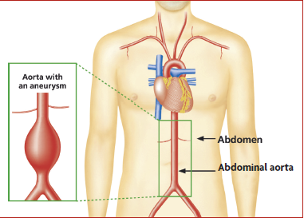
If you have an AAA, you will usually not notice any symptoms. This means you cannot tell if you have one, as you will not feel any pain or notice anything different. You may feel completely healthy.

Who should be screened?
We are inviting all men in their 65th year to take part in the AAA screening programme because the condition is most common in men aged 65 and over. Men aged over 65 who have not been screened before can ask for a screening appointment by contacting the screening programme office on 028 9615 1212.

Is an AAA serious?
- The aorta is normally less than 30mm wide.
- A small AAA (30–44mm wide) is not serious, but needs to be monitored to see if it grows.
- A medium AAA (45–54mm wide) also needs to be monitored as it could become serious if it continues to grow.
- A large AAA (55mm or more wide) is rare but can be very serious. As the wall of the aorta stretches, it becomes weaker and can burst. A burst AAA leads to serious internal bleeding, which is fatal in 8 out of 10 cases.

How can I find out more?
For more information about anything in this leaflet, you can:
- call the AAA screening programme office on 028 9615 1212
- visit: www.nidirect.gov.uk/aaa
- contact your GP.
Published May 2023 by the Public Health Agency.
Document ends.

